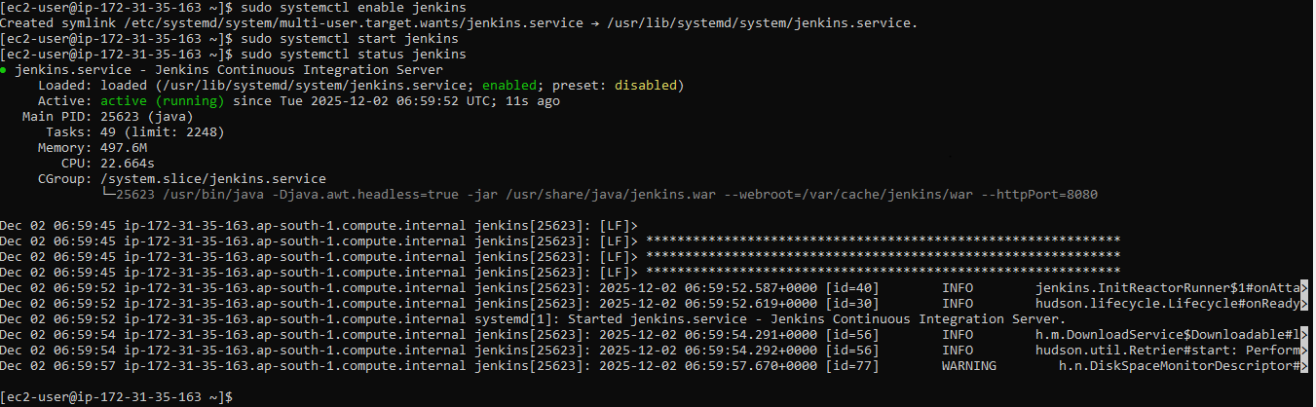

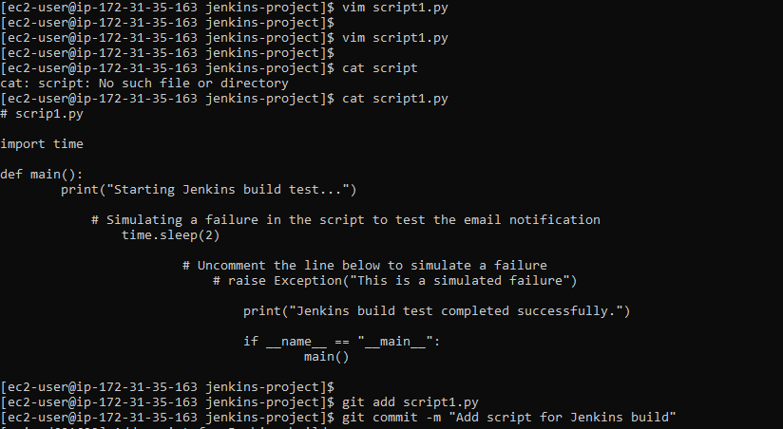

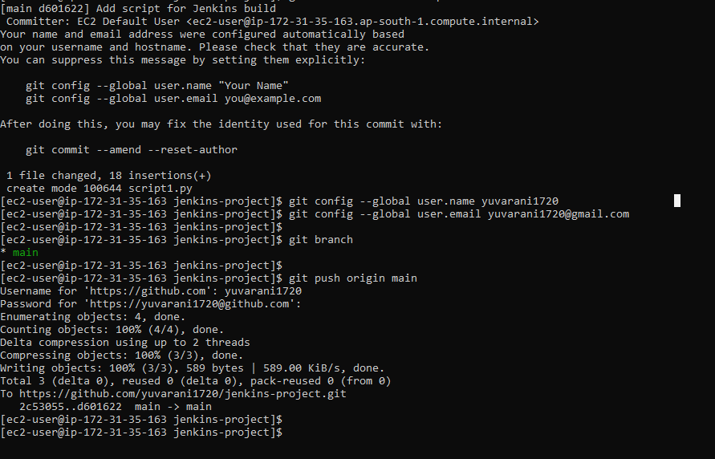

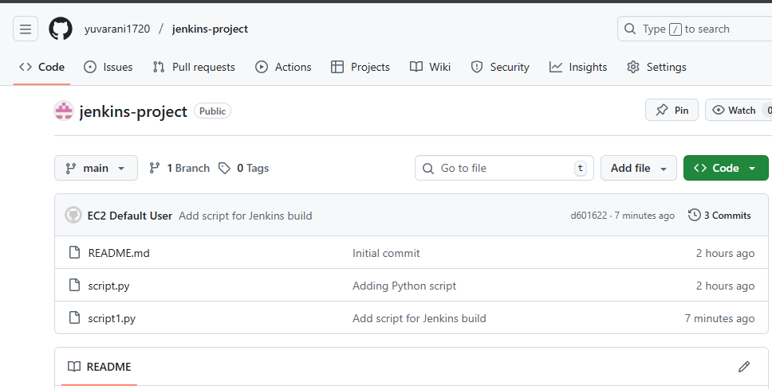

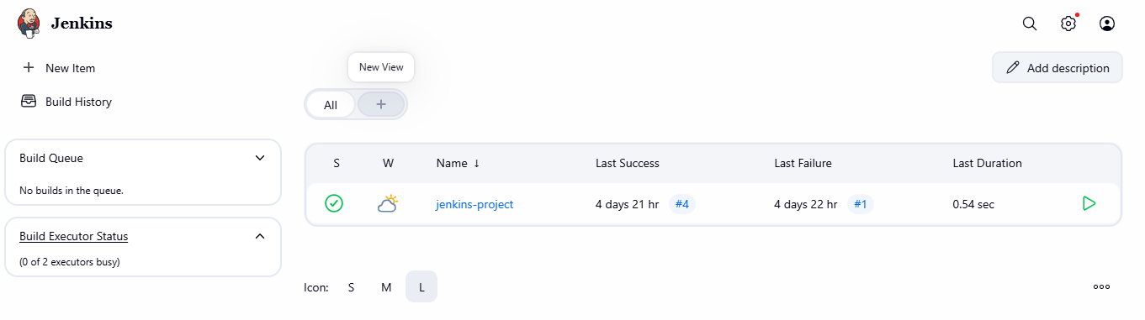

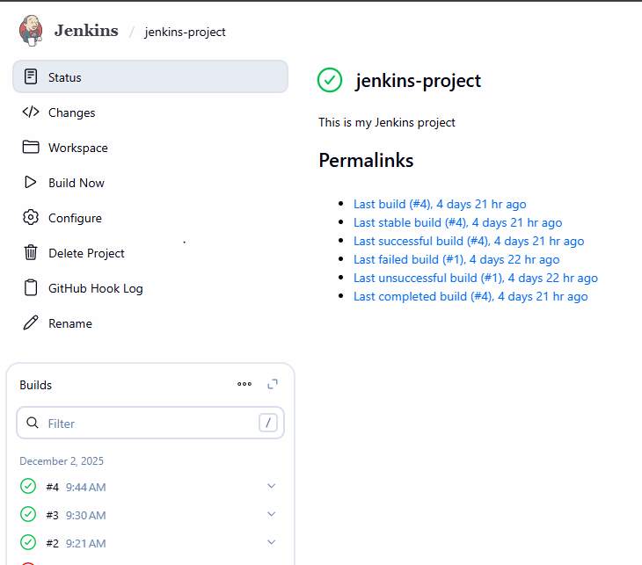

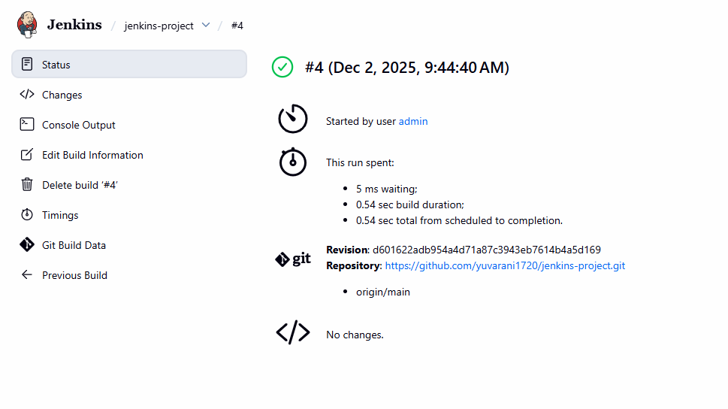
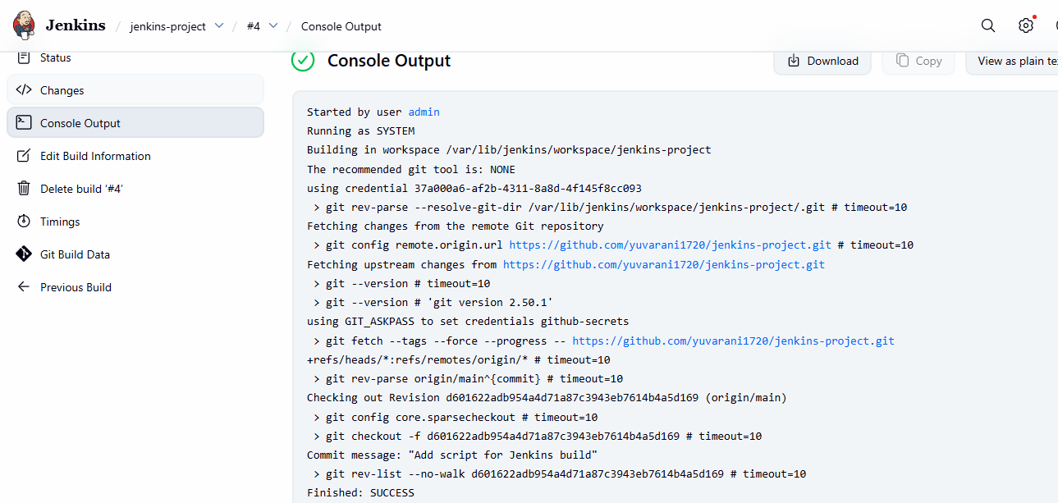

Started by user admin
Running as SYSTEM
Building in workspace /var/lib/jenkins/workspace/jenkins-project
The recommended git tool is: NONE
using credential 37a000a6-af2b-4311-8a8d-4f145f8cc093
> git rev-parse --resolve-git-dir /var/lib/jenkins/workspace/jenkins-project/.git # timeout=10
Fetching changes from the remote Git repository
> git config remote.origin.url https://github.com/yuvarani1720/jenkins-project.git # timeout=10
Fetching upstream changes from https://github.com/yuvarani1720/jenkins-project.git
> git --version # timeout=10
> git --version # 'git version 2.50.1'
using GIT_ASKPASS to set credentials github-secrets
> git fetch --tags --force --progress -- https://github.com/yuvarani1720/jenkins-project.git +refs/heads/*:refs/remotes/origin/* # timeout=10
> git rev-parse origin/main^{commit} # timeout=10
Checking out Revision d601622adb954a4d71a87c3943eb7614b4a5d169 (origin/main)
> git config core.sparsecheckout # timeout=10
> git checkout -f d601622adb954a4d71a87c3943eb7614b4a5d169 # timeout=10
Commit message: "Add script for Jenkins build"
> git rev-list --no-walk d601622adb954a4d71a87c3943eb7614b4a5d169 # timeout=10
Finished: SUCCESS

